CSA0502 – QUERY PROCESSING FOR DATASCIENCE
Lab Programs

5. Create a bar plot of Alphabet Inc. trading volume
CODE:
import pandas as pd
import matplotlib.pyplot as plt
data = {
"Date": ["2024-01-01", "2024-01-02", "2024-01-03",
"2024-01-04", "2024-01-05"],
"Volume": [1200000, 1500000, 1100000, 1800000, 1700000]
}
df = pd.DataFrame(data)
df["Date"] = pd.to_datetime(df["Date"])
plt.bar(df["Date"].astype(str), df["Volume"])
plt.title("Alphabet Inc. Trading Volume")
plt.xlabel("Date")
plt.ylabel("Volume")
plt.xticks(rotation=45)
plt.show()
OUTPUT:
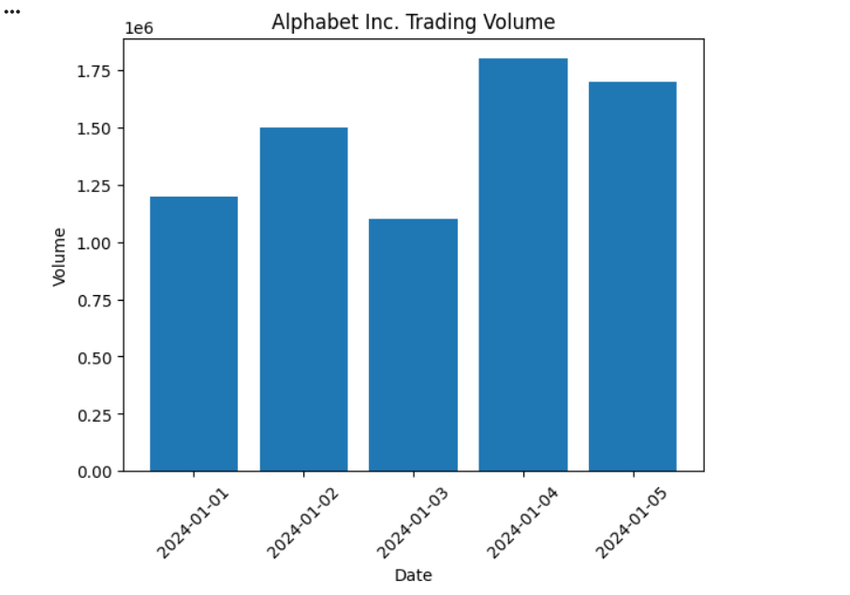

6. Scatter Plot
Aim
To create a scatter plot of Alphabet Inc. stock prices and trading volume.
Code
import pandas as pd
import matplotlib.pyplot as plt

data = {
"Date":["2024-01-01","2024-01-02","2024-01-03","2024-01-04","2024-01-05"],
"StockPrice":[140,142,145,143,148],
"Volume":[1200,1500,1300,1800,1700]
}

df = pd.DataFrame(data)

plt.scatter(df["StockPrice"], df["Volume"])
plt.title("Stock Price vs Trading Volume")
plt.xlabel("Stock Price")
plt.ylabel("Trading Volume")
plt.show()
OUTPUT:
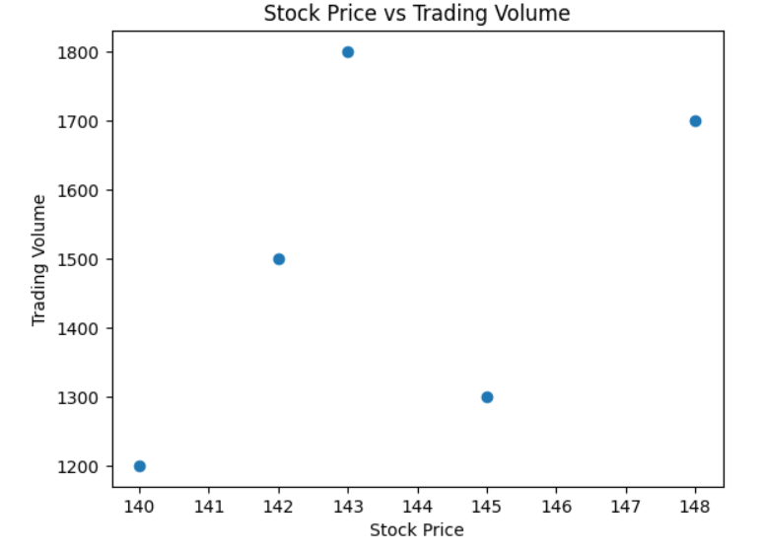
Result
Scatter plot created successfully.

